Click here to enter text.

Click here to enter text.

Project Notes

Specimen Notes

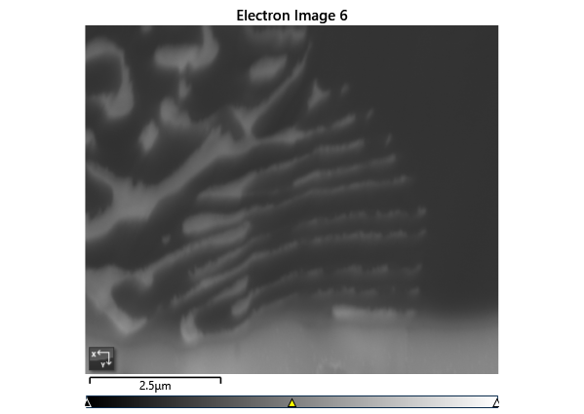

Settings

|  |  |
| --- | --- |
| Accelerating Voltage | 20.00 kV |
| Specimen Tilt (degrees) | 70.00 ° |
| Hit Rate | 86.62 % |
| Speed of Acquisition | 5.23 Hz |

Phases for Acquisition

|  |  |  |  |  |  |  |  |  |
| --- | --- | --- | --- | --- | --- | --- | --- | --- |
| Phase | a | b | c | Alpha | Beta | Gamma | Space Group | Database |
| Fe-FCC | 3.66 Å | 3.66 Å | 3.66 Å | 90.00 ° | 90.00 ° | 90.00 ° | 225 | OINA Phases |
| Fe-BCC | 2.87 Å | 2.87 Å | 2.87 Å | 90.00 ° | 90.00 ° | 90.00 ° | 229 | OINA Phases |
| Pb | 3.27 Å | 3.27 Å | 5.39 Å | 90.00 ° | 90.00 ° | 120.00 ° | 194 | ICSD |

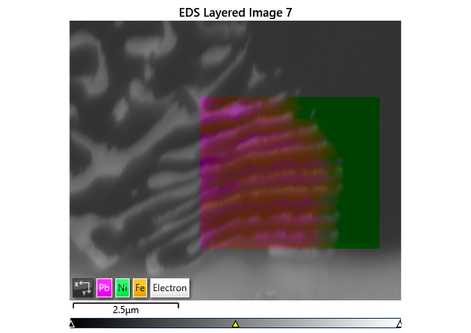

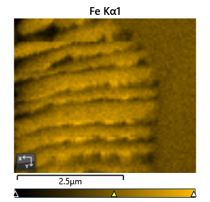

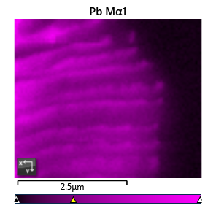

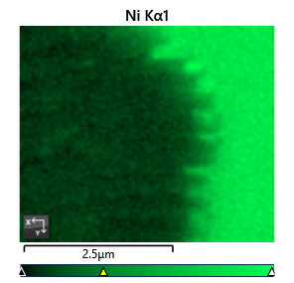

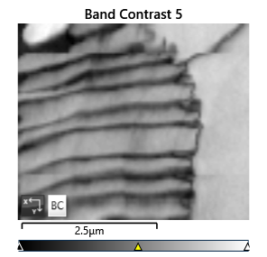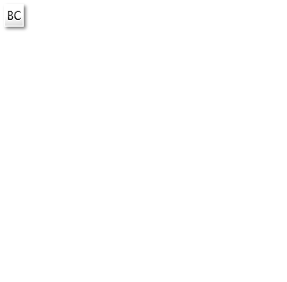

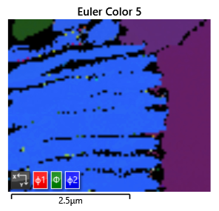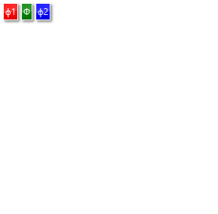

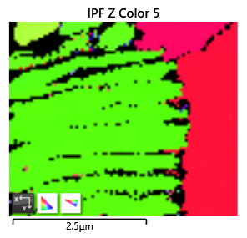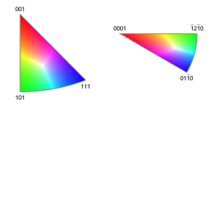

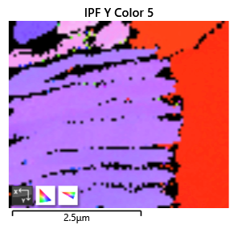

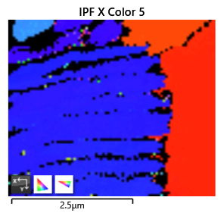

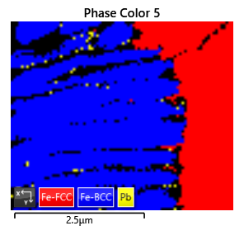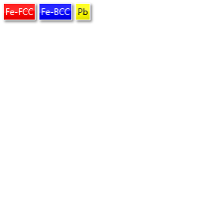

Phase Fraction

|  |  |  |  |  |  |  |  |  |  |  |
| --- | --- | --- | --- | --- | --- | --- | --- | --- | --- | --- |
| Phase Name | Phase Fraction (%) | Phase Count | Mean Band Contrast | Standard Deviation Band Contrast | Min Band Contrast | Max Band Contrast | Mean MAD | Standard Deviation MAD | Min MAD | Max MAD |
| Fe-FCC | 26.97 | 1693 | 114.46 | 10.69 | 52.00 | 127.00 | 0.72 | 0.12 | 0.33 | 1.72 |
| Fe-BCC | 58.90 | 3698 | 90.76 | 14.58 | 41.00 | 141.00 | 0.83 | 0.17 | 0.28 | 1.96 |
| Pb | 0.75 | 47 | 66.81 | 12.06 | 39.00 | 91.00 | 1.25 | 0.34 | 0.63 | 1.92 |
| Zero Solutions | 13.38 | 840 | 60.68 | 13.77 | 0.00 | 104.00 |  |  |  |  |